Name: Krish Singh
Roll: AID25072
B.Tech Artificial Intelligence & Data Science - 2nd Semester
Object Oriented Programming – Lab Assignment 10
Program 1: Creating and Using a User-Defined Package
Calculator.java :

package mypackage;
public class Calculator{
public int add(int a, int b){
return a+b;
}
public int sub(int a, int b){
return a-b;
}
}

MainApp.java :
import mypackage.Calculator;
public class MainApp{
public static void main(String[] args){
Calculator obj = new Calculator();
System.out.println("Addition: "+obj.add(10,5));
System.out.println("Subtraction: "+obj.sub(10,5));
}
}

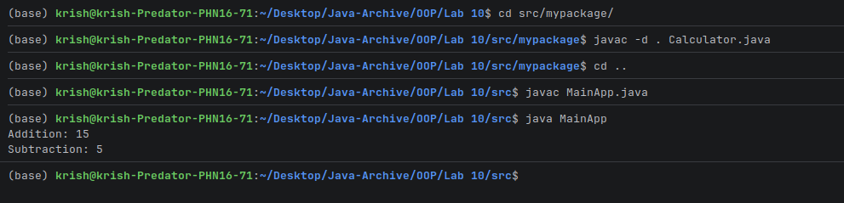
Output:

Program 2: Using Fully Qualified Name (Without import)

Demo.java :
public class Demo{
public static void main(String[] args) {
mypackage.Calculator obj = new mypackage.Calculator();
System.out.println("Addition : "+obj.add(7,3));
}
}
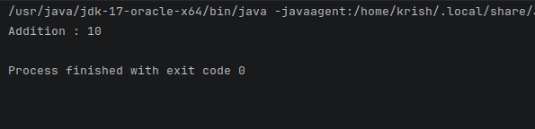
Output:

Program 3: Creating and Using a Sub-Package

Message.java :

package com.company.utils;
public class Message {
public void display(){
System.out.println("Hello from subpackage");
}
}

Main.java :

import com.company.utils.Message;
public class Main {
public static void main(String[] args) {
Message msg = new Message();
msg.display();
}
}

Output:
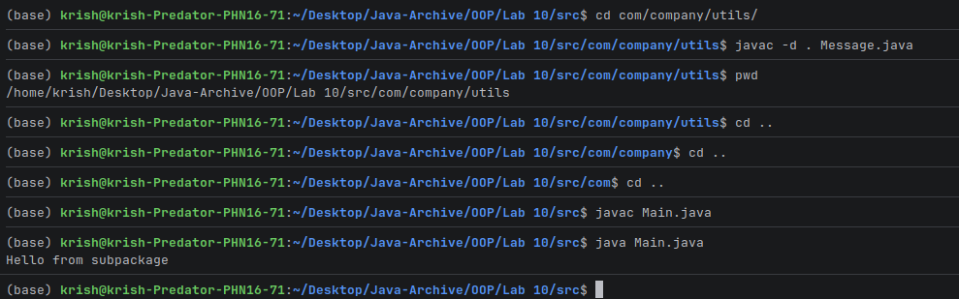

Program 4: Accessing Classes from Another Package

A.java :

package pack1;
public class A{
public void show(){
System.out.println("Inside Package Pack1");
}
}

B.java :

package pack2;
import pack1.A;
public class B{
public static void main(String[] args){
A obj = new A();
obj.show();
}
}

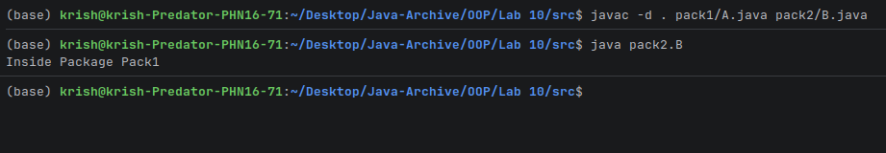
Output:

